

# Are You Looking and Feeling As Great As You Could Be?

***“Take Care Of Your Body, It Is The Only Place You Have To Live In”***

4 Key Steps To Maximize Energy

& Weight-Loss!

***Solution 1:***

Stop The Cardio Madness

The correct form of exercise is the difference between plateaus and maximized weight-loss and energy!Interval training boosts metabolism significantly longer than a steady workout of equal or even greater length (for example, a 20 minute workout of alternating high/low-intensity periods burns more calories than a 20 minute workout of stead intensity). Interval training also builds lean muscle tissue faster than steady state training.

It is important to push the body to maximum effort to achieve muscle fatigue and maximum oxygen use in quick bursts. The harder muscles work, the more oxygen they require. This is measured relative to one’s VO2 max, which is the highest amount of oxygen your body consumes during exercise. Working your body close to its VO2 max triggers the after-burn effect, where the body continues to consume oxygen and burn calories up to 48 hours after the workout. Studies show that 27 Minutes of Interval training 3x/week produces the same anaerobic and aerobic improvements as 60 minutes of cardio 5x/week.

.

***Solution 2:***

Catch Some ZZZ’s

You can actually sleep your way to weight-loss! An analysis by researchers at Columbia University found that people who sleep less than seven hours per night are heavier, gain more weight over time, and have a harder time losing weight! If you're trying to slim down or shape up, hitting the sack is just as important as sweating at the gym.

Not only do you have more energy to take on the day after a good night’s sleep, but your body also torches calories, even when you’re not working out. A study from the *American Journal of Clinical Nutrition* found that normal sleepers' resting energy expenditure—the amount of calories burned when you’re not moving—was five percent higher than their tired counterparts. They also burned 20% more calories after a meal versus sleep-deprived people.

To top it off, sleep encourages portion control and reduces cravings! In a Swedish study, well-rested and sleep-deprived participants were asked to complete a computerized "ideal portion size" task where they could manipulate their serving size on a screen. Their findings: Sleep-starved people added 35 additional calories in snacks to their digital “plate” compared to well-rested participants.

***Solution 4:***

Kick Sugar To The Curb

While most of us on a weight loss mission concentrate on lowering fats, many of us fail to consider the role that refined sugar plays in our diets and in contributing to our growing waistlines.   Large amounts of refined sugar are often hidden in many of the foods and drinks we consume every day without us even knowing it. Although many of us think of sugar as being a relatively simple concept, the fact is that sugars can be quite complicated to understand.    On food labels sugar can be listed as brown sugar, palm sugar, cane sugar, corn syrup, fructose, fruit juice concentrate, glucose (dextrose), high-fructose corn syrup, honey, invert sugar, lactose, maltose, molasses, raw sugar, (table) sugar (sucrose), syrup.

**Negative effects of sugar:**

* Simple sugars on their own have no nutritional value (no vitamins, minerals, etc).
* The average American currently consumes more than 90 pounds of sugar per year
* Cause our bodies to begin storing & stop burning fat.
* Can cause an insulin drop (following a surge), which can leave us feeling tired and hungry (usually for something else very sweet).
* Suppressing the immune system.
* Upsetting the body's mineral balance.
* Contributes to hyperactivity, anxiety and depression.
* Causing kidney damage
* Decreases Energy
* Increasing the risk of coronary heart disease.
* Interfering with the absorption of calcium and magnesium.
* Contributing to diabetes.
* Contributing to osteoporosis.
* Causing food allergies
* Increasing fluid retention.

To help you ferret out which products are surprisingly high in sugar, I embarked on a mission in the aisles of my local market, I have examined hundreds of nutrition information labels to check out the sugar content in foods.

***Solution 3:***

Pucker Up

It is time to drink some Apple Cider Vinegar! Apple Cider Vinegar has been long valued for its many health benefits. Recent research shows at least three ways in which the traditional healers were on the right track at least when it comes to weight loss. A 2006 review article in the "Medscape Journal of Medicine" concludes vinegar may have a role in blood sugar control and appetite suppression. Other studies show vinegar promotes weight loss by preventing fat accumulation through its impact on insulin secretion.

If you want to cut down on nibbling between meals try vinegar. In a 2005 study in the "European Journal of Clinical Nutrition," scientists fed bread plus low, medium or high amounts of vinegar to twelve healthy subjects, while the control group ate plain bread. Those who received the vinegar felt fuller than the control group, and the effect increased with the amount of vinegar ingested. While vinegar soaked bread may not be your favorite dish, you might try sipping vinegar in water along with your meal or having a salad dressed with vinegar and oil.

In a 2004 study in "Diabetes Care," insulin-resistant individuals who drank vinegar and water followed by a meal enjoyed significantly improved insulin sensitivity compared to a control group. The study authors concluded that vinegar's effects may be similar to those of some popular diabetes drugs. Of course given the connection between insulin levels and fat storage, these results support vinegar's use as a fat burning food.



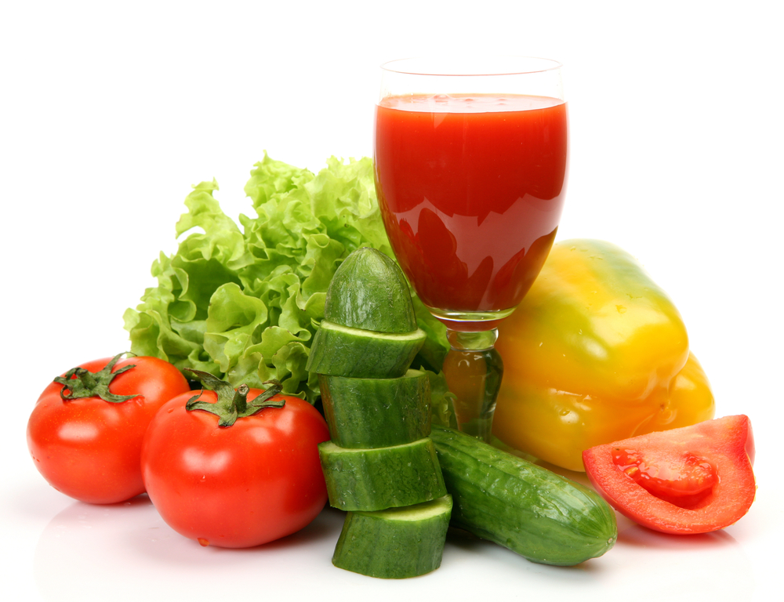

www.hfcwellness.com

*BONUS:*

28 Days To Slim Diet

1. NO artificially sweetened "sugar free" foods –(and drinks) They make you fat and reek havoc on your body!
2. Don’t Go Hungry – Use snacks that’ll fill you up, and curb your cravings but won't add any significant extra calories. When you feel starved, you’ll crave foods which will add unwanted body fat and make you feel really guilty
3. Eat within 1 hour of waking up! This should consist of a protein and some form of a fresh WHOLE fruit or vegetable.
4. Drink Half Your Body Weight In Ounces Of Water Per Day.
5. Skip The Coffee! You want to be able to access and harness your NATURAL energy sources!
6. Stop Eating By 7pm. Not only does eating late disrupt your sleeping patterns but also is a sure way to pack on the pounds!
7. Be In Bed By 11:00pm. When you go to be after 11:00pm your body gets a natural second wind, which causes you to not sleep as soundly.
8. No Alcohol- Many people hate this one but it is essential if you are trying to work off the pounds or trying to optimize your health!
9. Workout 5 Days Per Week- Once again, calories in vs. calories out! How many calories are you burning? Make sure that you push yourself to try new things and to redefine your comfort zone!
10. Cut out ALL wheat, breads, pastas, & dairy for 28 Days! They are huge culprits to increasing your cravings and waistline while depleting you of your energy! Fill your diet with tons of vegetables and normal portions of fruits, nuts, and lean protein sources.

**Sugar Shockers-** Foods Surprisingly High In Sugar

One thing’s for sure: Just because there’s a nutrition-oriented statement on the package (like "contains whole grain," "excellent source of calcium," "fat-free," "100% juice" or "25% less sugar") doesn’t mean it *doesn’t* contain a shocking amount of sugar. And just because the brand name or product name sounds like it’s good for weight loss (Weight Watchers, Skinny Cow, etc.), don’t assume the food is lower in sugar.

So how much exactly is a gram of sugar? ***One teaspoon of granulated sugar equals 4 grams of sugar.*** To put it another way, 16 grams of sugar in a product is equal to about 4 teaspoons of granulated sugar.

So how much is in your common foods **PER SERVING?**

1. **Canned or Packaged Fruit**

17-26g of sugar = 4.25-6.5 tsps sugar

1. **“Healthy” Cereal Bars**

12-19g of sugar = 4-4.75 tsps sugar

1. **So- Called “Healthy” Cereals**

11-17g of sugar = 2.75-4.25 tsps sugar

1. **Spaghetti Sauce**

5-12g of sugar = 1.25-3 tsps sugar

1. **BBQ Sauce**

12-15g of sugar = 4-3.75 tsps sugar

1. **Fruit Juice**

18-36g of sugar = 4.5-9 tsps sugar

1. **Yogurt**

27-31g of sugar = 6.75-7.75 tsps sugar



www.hfcwellness.com

11391-C Nuckols Road

Glen Allen, VA 23059

804-270-6010